Create a windows Vm machine in AWS and connect with RDP open CMD in windows share the about system info.

Creating a windows virtual machine:

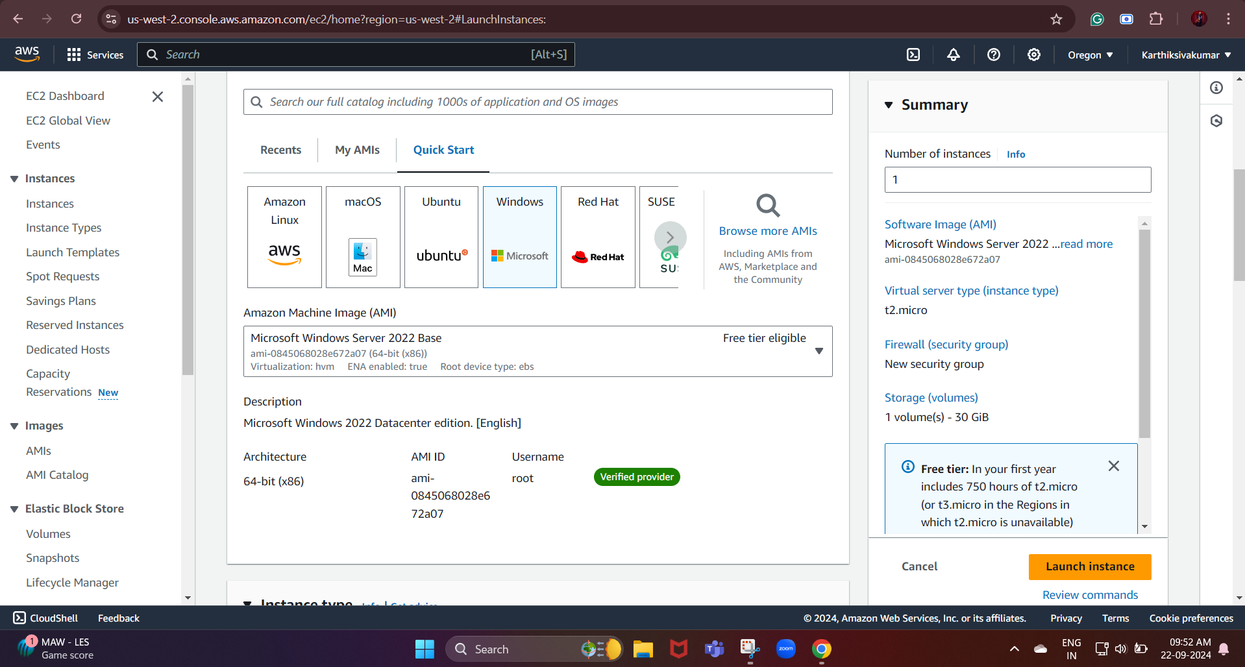

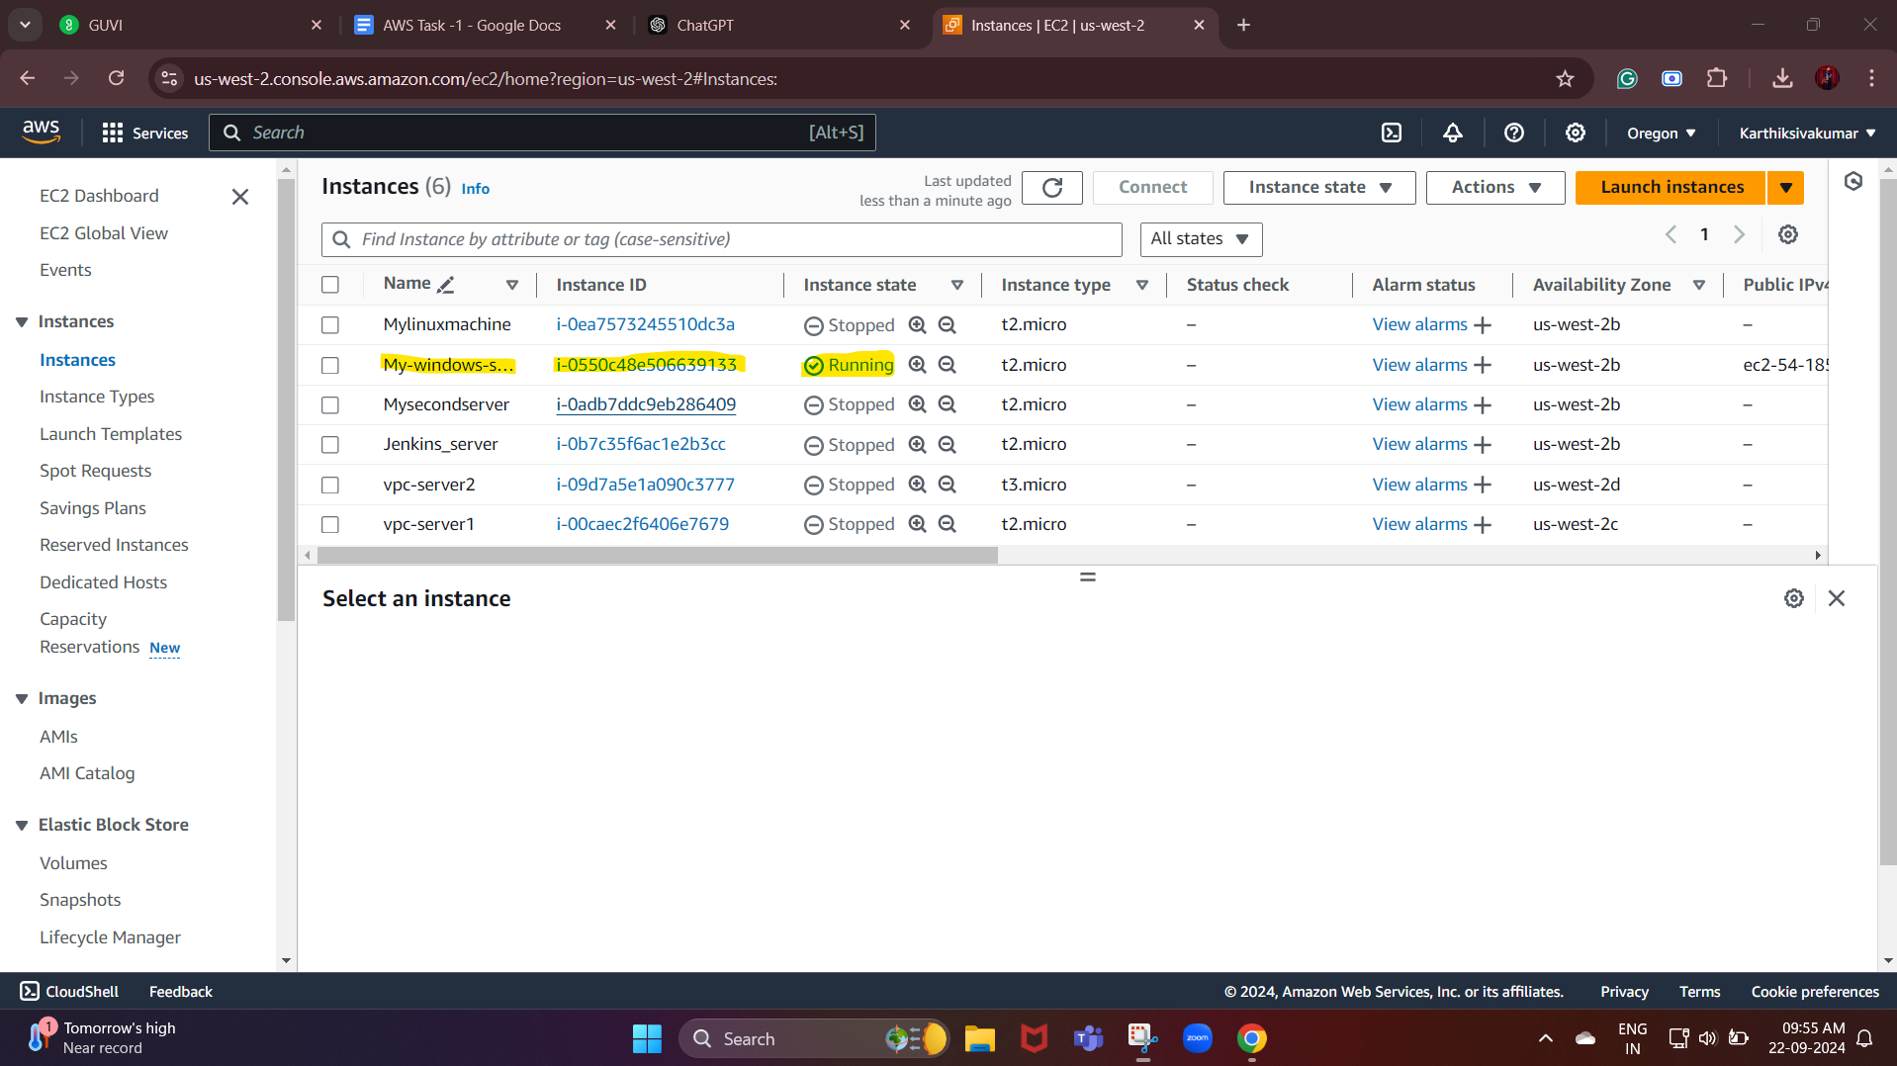

Now, we are going to connect the Windows VM via RDP

RDP - Remote Desktop Protocol

Remote Desktop Protocol (RDP), a secure network communication protocol offered by Microsoft, allows users to execute remote operations on other computers.

* First, we need to remote the desktop connection tool on our local machine.

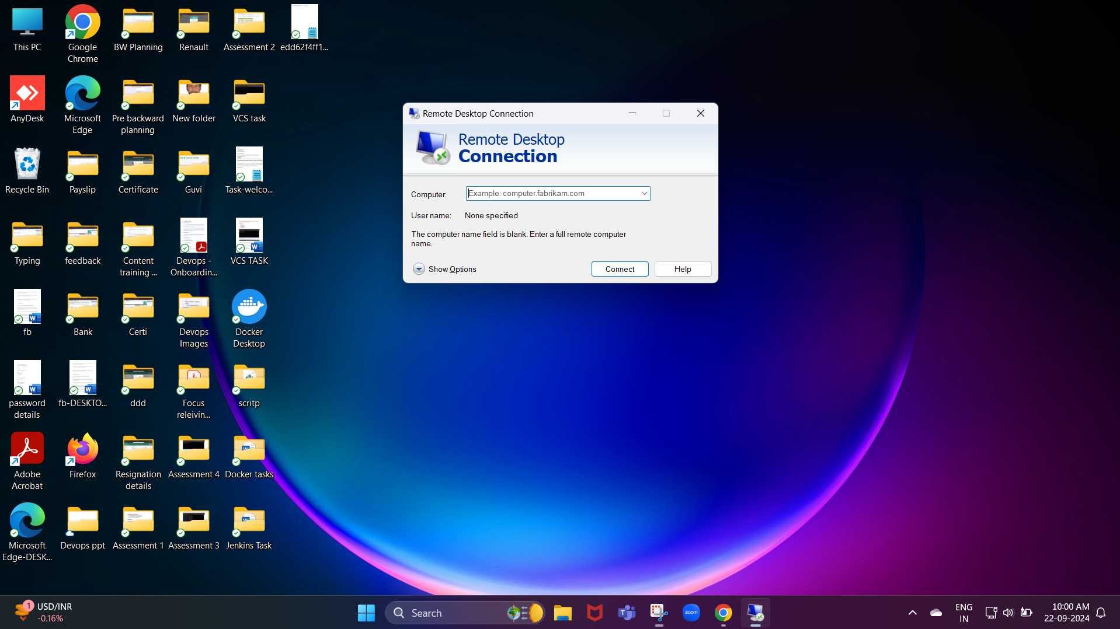

* Next, we need to enter the public IP of the instance we created.

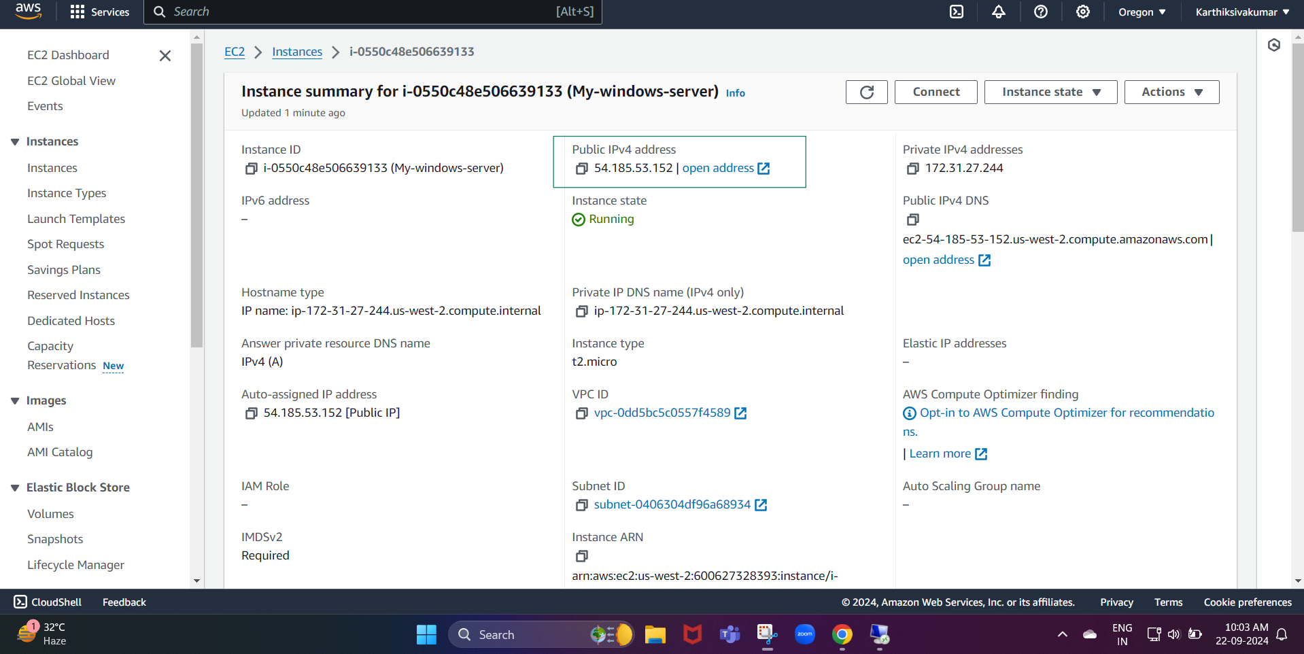

We need to give the username and password of the connection of RDC

Under Connect to your instance, there is an option that says "Get Windows Password." Click on it.

AWS will prompt you to upload the .pem key pair file that you downloaded when launching the instance.

Browse your local computer to find the .pem file you created during the instance launch process.

After uploading the .pem file, AWS will use it to decrypt the Administrator password.

Click on the Decrypt Password button to reveal the password.

Once the password is decrypted, copy it. You will use this password to log into the instance via RDP.

Now that you have the decrypted password, use it in your Remote Desktop Connection tool to log into your Windows VM.

